Selected Bibliography
OTHER WORKS BY THE AUTHOR:
King, Martin Luther, Ir. Stride Toward Freedom: The Montgomery Story Harper & Brothers, 1958.
The Strength to Love. Harper & Row, 1963.
VVhere Do We Gofrom Here: Chaos or Community? Harper & Row, 1967.
The Trumpet ofConscience. Harper & Row, 1967.
A Testament ofHope. James M. Washington, ed. Harper-Collins Publishers, 1986.
FURTHER READING:
Ansbro, John. Martin Luther King, Ir.: The Making of" Mind. Orbis Books, 1982.
Bennett, Lerone, Jr. What Manner ofMan. Johnson Publishing Co, 1968.
Branch, Taylor. Parting the Waters: America m the King Years, 1954-1963. Simon & Schuster, 1989.
Garrow, David. Bun-mg the Cross: Martin Luther King, Jr. W W. Norton, 1981.
King, Coretta Scott. My Life with Martin Luther King, Jr. Holt, Rinehart, and Winston, 1969. The Words ofMarti" Luther King, Jr Newmarket Press, 1983.
Lewis, David L King. A Biography: University of Illinois Press, 1970, 1978.
Oates, Stephen B. Let the Trumpet Sound: The Life ofMnrtin Luther King, Jr. New American Library, 1982. Reddick, Lawrence D. Crusader Without Violence A Biography ofMartin Luther King, Jr. Harper & Brothers, 1959. Schulke. Flip, and Penelope O. McPhee. King Remembered. W W Norton, 1986.
126
KING
LEGACY
The King Legacy Series
In partnership with the Estate of Dr. Martin Luther King, Jr., Beacon Press is proud to share the great privilege and responsibility of furthering Dr. King's powerful message of peace, nonviolence, and social justice with a historic publishing program—The King Legacy.
The series will encompass Dr. Kin* most important writings, including sermons, orations, lectures, prayers, and all of his previously published books that are currently out of print. Published accessibly and in multiple formats, each volume will include new material from acclaimed scholars and activists, underscoring Dr. Kin$ continued relevance for the twenty-first century, and bringing his message to a new generation of readers.
thekinglegacy.org
128
25 Beam Street
Bostml, 02108-2892 www.beam.o
Beæ Me u mier awpices of of Pre-" Unituian
Pmgrm at Rock its supp-M-t of the King Legacy
No of this my be wlutsoevu in c a« of Ivief embodied in fm- mre inf.timl, 21 26th Street, NY 10010.
Copyright g 1963, IY64 by Mutin Luther King, Jr. Copyright 1986 by Scott King, King, Mutin Luther King Ill, Yolm*a King, King. All rights copyright 2010 All rights

KING IPM
G A C V In With
This of Why We Wait is euliu dition, in States 1963. spelling adjustd, us luve
in the United States of
Amica

14 13 12 118765432 1
Lilwy of Cataloging in Data
King, Martin Luther, 1929-1968.
Why wait / Mutin King, Jr.
Ongimlly New York : 1964_
and
E-PUB ISBN 978-08070-0113-4
ISBN 978-0-8070-0114-1 : alk
ISBN 978-0-8070-0112-7 (pbk_ : paper)
l. rights. 2_ 3. Unit«3 4. l. Title.
E185_61.K54 2010
323.11960730761781—dc22 2010027828

Dr. King walks to a
To Kings right is Ralph
A is by dogs in
on May 16, 1963, in
The Me unidentifia May 3, 1963. He in of
129

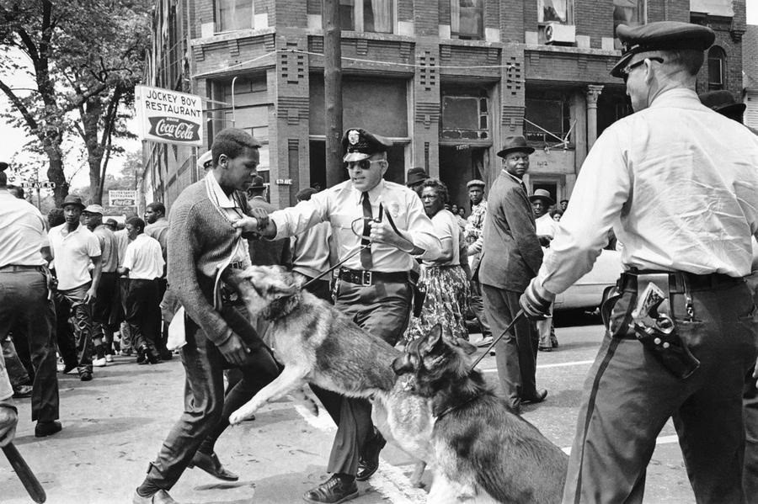
Back cover: " A seventeen-year-old demonstrator is set upon by dogs" May 3, 1963 < Google terms
https://cdn.theatlantic.com/assets/media/img/photo/2013/02/50-years-ago-the-world-in-1963/f19_

